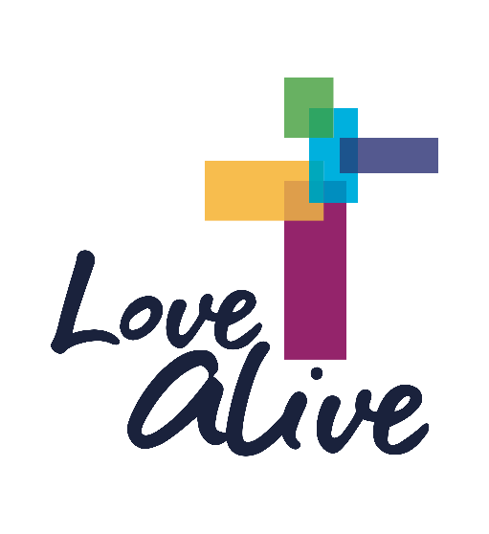

Dear Short North Church,
We want to be good neighbors and watch out for the most vulnerable among us.
Therefore, we encourage EVERYONE to stay home and worship with us online at 10:00 AM.
Go to www.shortnorthchurch.org/live-streaming/ There will also be no nursery, children, or youth activities until further notice. Watch your inbox for activities to do with your children at home.
Breakfast Church will take place 7:00-9:00 AM outside thru the end of March. There will be stations to pick up a breakfast "to go" as well as a prayer station. If you are healthy and not in the "at-risk" category, please Susan (susan@newlifecolumbus.com) from the NLCO to volunteer.
Financial support for our Love Alive mission is crucial. Please consider setting up automatic giving by going to www.shortnorthchurch.org and clicking on the GIVE button in the middle of the page. This enables us to have a consistent flow of resources regardless of how we meet. You can also text LOVEALIVE to 73256 or send a check to Short North Church, 25 W. 5th Ave, Columbus, OH 43201.
"Throw all your anxiety onto God, because God cares about you." 1 Peter 5:7
In the midst of the uncertainty about the virus and its impact, we can be certain that God is with us, ALL of us! So, let's lean in to Love with all that we've got - praying, encouraging, worshiping, giving, and caring for one another.
This information is current as of 3:00 PM on Thursday afternoon. Please continue to watch your email inbox and social media for updates as they become available.
Onward in Love together,
Pastor Amy & Pastor Marcus

